

Project report

Artificial Intelligence

# QUESTION-1:

import pygame

import heapq

import random

import time

# Define colors

BLACK = (0, 0, 0)

WHITE = (255, 255, 255)

GREEN = (0, 255, 0)

RED = (255, 0, 0)

BLUE = (0, 0, 255)

BROWN = (165, 42, 42)

GRAY = (128, 128, 128)

YELLOW = (255, 255, 0)

# Define grid size

GRID_SIZE = 15

# Define window size

WINDOW_SIZE = [600, 600]

# Define cell size

CELL_SIZE = WINDOW_SIZE[0] // GRID_SIZE

# Define obstacle probability

OBSTACLE_PROBABILITY = 0.3  # Increased probability

# Define delivery locations

DELIVERY_LOCATIONS = []

for _ in range(5):

    x = random.randint(0, GRID_SIZE - 1)

    y = random.randint(0, GRID_SIZE - 1)

    DELIVERY_LOCATIONS.append((x, y))

# Initialize pygame

pygame.init()

# Set up the window

window = pygame.display.set_mode(WINDOW_SIZE)

pygame.display.set_caption("Autonomous Delivery Robot")

# Define the grid

grid = [[0 for _ in range(GRID_SIZE)] for _ in range(GRID_SIZE)]

# Generate obstacles and cars

for i in range(GRID_SIZE):

    for j in range(GRID_SIZE):

        if random.random() < OBSTACLE_PROBABILITY:

            grid[i][j] = random.choice([2, 3, 4])  # Representing different types of obstacles

        elif random.random() < 0.05:  # Adjust this probability as needed

            grid[i][j] = 5  # Representing cars

# Ensure robot and delivery locations are not blocked

grid[0][0] = 0  # Robot initial location

for loc in DELIVERY_LOCATIONS:

    grid[loc[0]][loc[1]] = 0

# Define the heuristic function

def heuristic(a, b):

    (x1, y1) = a

    (x2, y2) = b

    return abs(x1 - x2) + abs(y1 - y2)

# Define the A* algorithm

def astar(start, goal):

    frontier = []

    heapq.heappush(frontier, (0, start))

    came_from = {}

    cost_so_far = {}

    came_from[start] = None

    cost_so_far[start] = 0

    while frontier:

        current = heapq.heappop(frontier)[1]

        if current == goal:

            path = []

            while current != start:

                path.append(current)

                current = came_from[current]

            path.append(start)

            path.reverse()

            return path

        for next in [(current[0] + 1, current[1]), (current[0] - 1, current[1]),

                     (current[0], current[1] + 1), (current[0], current[1] - 1)]:

            if 0 <= next[0] < GRID_SIZE and 0 <= next[1] < GRID_SIZE and grid[next[0]][next[1]] == 0:

                new_cost = cost_so_far[current] + 1

                if next not in cost_so_far or new_cost < cost_so_far[next]:

                    cost_so_far[next] = new_cost

                    priority = new_cost + heuristic(next, goal)

                    heapq.heappush(frontier, (priority, next))

                    came_from[next] = current

    return []

def main():

    global DELIVERY_LOCATIONS

    running = True

    path = []

    start = (0, 0)

    while running:

        for event in pygame.event.get():

            if event.type == pygame.QUIT:

                running = False

        # Clear the window

        window.fill(WHITE)

        # Draw the grid

        for i in range(GRID_SIZE):

            for j in range(GRID_SIZE):

                rect = pygame.Rect(j * CELL_SIZE, i * CELL_SIZE, CELL_SIZE, CELL_SIZE)

                if grid[i][j] == 1:  # Normal grid

                    pygame.draw.rect(window, WHITE, rect, 1)

                elif grid[i][j] == 2:  # Trees

                    pygame.draw.rect(window, GREEN, rect)

                elif grid[i][j] == 3:  # Buildings

                    pygame.draw.rect(window, GRAY, rect)

                elif grid[i][j] == 4:  # Houses

                    pygame.draw.rect(window, BROWN, rect)

                elif grid[i][j] == 5:  # Cars

                    pygame.draw.rect(window, YELLOW, rect)

        # Draw the delivery locations

        for loc in DELIVERY_LOCATIONS:

            pygame.draw.circle(window, BLUE, (loc[1] * CELL_SIZE + CELL_SIZE // 2, loc[0] * CELL_SIZE + CELL_SIZE // 2), CELL_SIZE // 4)

        # Draw the robot

        pygame.draw.circle(window, RED, (start[1] * CELL_SIZE + CELL_SIZE // 2, start[0] * CELL_SIZE + CELL_SIZE // 2), CELL_SIZE // 3)

        # Draw the path

        if path:

            for i in range(len(path) - 1):

                pygame.draw.line(window, BLUE, (path[i][1] * CELL_SIZE + CELL_SIZE // 2, path[i][0] * CELL_SIZE + CELL_SIZE // 2),

                                 (path[i + 1][1] * CELL_SIZE + CELL_SIZE // 2, path[i + 1][0] * CELL_SIZE + CELL_SIZE // 2), 3)

        # Update the display

        pygame.display.flip()

        # Deliver items

        if DELIVERY_LOCATIONS:

            current_goal = min(DELIVERY_LOCATIONS, key=lambda loc: heuristic(start, loc))

            path = astar(start, current_goal)

            if path:

                while path:

                    next_step = path.pop(0)

                    pygame.draw.line(window, BLUE, (start[1] * CELL_SIZE + CELL_SIZE // 2, start[0] * CELL_SIZE + CELL_SIZE // 2),

                                     (next_step[1] * CELL_SIZE + CELL_SIZE // 2, next_step[0] * CELL_SIZE + CELL_SIZE // 2), 3)

                    start = next_step

                    pygame.draw.circle(window, RED, (start[1] * CELL_SIZE + CELL_SIZE // 2, start[0] * CELL_SIZE + CELL_SIZE // 2), CELL_SIZE // 3)

                    pygame.display.flip()

                    time.sleep(0.3)

                DELIVERY_LOCATIONS.remove(current_goal)

        else:

            # Return to initial location

            path_back = astar(start, (0, 0))

            if path_back:

                while path_back:

                    next_step = path_back.pop(0)

                    pygame.draw.line(window, BLUE, (start[1] * CELL_SIZE + CELL_SIZE // 2, start[0] * CELL_SIZE + CELL_SIZE // 2),

                                     (next_step[1] * CELL_SIZE + CELL_SIZE // 2, next_step[0] * CELL_SIZE + CELL_SIZE // 2), 3)

                    start = next_step

                    pygame.draw.circle(window, RED, (start[1] * CELL_SIZE + CELL_SIZE // 2, start[0] * CELL_SIZE + CELL_SIZE // 2), CELL_SIZE // 3)

                    pygame.display.flip()

                    time.sleep(0.3)

                    if not path_back:

                        DELIVERY_LOCATIONS.clear()  # All deliveries completed, clear the delivery locations list

            running = False  # Stop the loop once all deliveries are completed

    pygame.quit()

if __name__ == "__main__":

    main()

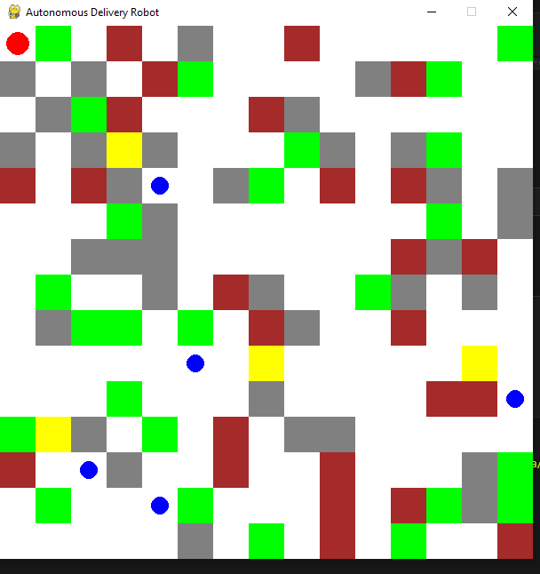

# QUESTION-2:

import tkinter as tk

from tkinter import ttk, messagebox, simpledialog

import time

class SudokuCSP:

    def __init__(self, board):

        if not all(len(row) == 9 for row in board) or len(board) != 9:

            raise ValueError("Board must be a 9x9 grid.")

        self.board = [row[:] for row in board]

        self.variables = [(i, j) for i in range(9) for j in range(9)]  # All cells are variables

        self.domains = {(i, j): list(range(1, 10)) if board[i][j] == 0 else [board[i][j]]

                        for i in range(9) for j in range(9)}

        self.neighbors = {v: self.find_neighbors(v) for v in self.variables}

    def find_neighbors(self, var):

        r, c = var

        neighbors = [(r, cc) for cc in range(9) if cc != c] + \

                    [(rr, c) for rr in range(9) if rr != r] + \

                    [(rr, cc) for rr in range((r // 3) * 3, (r // 3) * 3 + 3) for cc in

                     range((c // 3) * 3, (c // 3) * 3 + 3)

                     if (rr, cc) != var]

        return set(neighbors)

    def solve_with_backtracking(self):

        start_time = time.time()

        if self.backtrack():

            end_time = time.time()

            self.time_complexity = end_time - start_time

            return True

        return False

    def backtrack(self):

        unassigned = self.find_unassigned_location()

        if not unassigned:

            return True  # Puzzle solved

        row, col = unassigned

        for num in range(1, 10):  # Try all possible numbers

            if self.is_valid_assignment(row, col, num):

                self.board[row][col] = num

                if self.backtrack():

                    return True

                self.board[row][col] = 0  # Undo assignment (backtrack)

        return False  # Trigger backtracking

    def solve_with_ac3(self):

        start_time = time.time()

        if self.ac3():

            # If AC-3 prunes the domains successfully, try to solve the puzzle with backtracking

            if self.solve_with_backtracking():

                end_time = time.time()

                self.time_complexity = end_time - start_time

                return True

        else:

            # If AC-3 fails to prune the domains, return False indicating no solution

            return False

    def ac3(self):

        queue = [(xi, xj) for xi in self.variables for xj in self.neighbors[xi]]

        while queue:

            xi, xj = queue.pop(0)

            if self.revise(xi, xj):

                if not self.domains[xi]:

                    return False

                for xk in self.neighbors[xi]:

                    if xk != xj:

                        queue.append((xk, xi))

        return True

    def revise(self, xi, xj):

        revised = False

        domain_xi = self.domains.get(xi, [])

        domain_xj = self.domains.get(xj, [])

        for x in domain_xi[:]:

            if all(x != y for y in domain_xj) and self.check_sudoku_constraints(xi, x):

                self.domains[xi].remove(x)

                revised = True

        return revised

    def check_sudoku_constraints(self, var, value):

        row, col = var

        if any(value == self.board[row][j] for j in range(9)):

            return False

        if any(value == self.board[i][col] for i in range(9)):

            return False

        start_row, start_col = 3 * (row // 3), 3 * (col // 3)

        if any(value == self.board[i][j] for i in range(start_row, start_row + 3)

                                         for j in range(start_col, start_col + 3)):

            return False

        return True

    def find_unassigned_location(self):

        for i in range(9):

            for j in range(9):

                if self.board[i][j] == 0:

                    return i, j

        return None

    def is_valid_assignment(self, row, col, num):

        for k in range(9):

            if self.board[row][k] == num or self.board[k][col] == num:

                return False

        box_start_row, box_start_col = 3 * (row // 3), 3 * (col // 3)

        for i in range(box_start_row, box_start_row + 3):

            for j in range(box_start_col, box_start_col + 3):

                if self.board[i][j] == num:

                    return False

        return True

class SudokuGUI:

    def __init__(self, master):

        self.master = master

        master.title("Sudoku Solver")

        self.cells = {}

        # Initialize entry cells for the Sudoku grid

        for row in range(9):

            for col in range(9):

                entry = tk.Entry(master, width=3, font=('Arial', 18), borderwidth=2, justify='center')

                entry.grid(row=row, column=col, sticky='nsew', padx=1, pady=1)

                self.cells[(row, col)] = entry

        # Initialize control frame and other components after all entries are created

        self.initialize_controls()

        self.puzzles = {

            'Easy': [

                # Puzzle #1

                [

                    [0, 7, 0, 3, 5, 0, 8, 0, 0],

                    [0, 3, 8, 7, 1, 4, 0, 6, 9],

                    [6, 4, 5, 0, 0, 0, 7, 1, 3],

                    [5, 8, 0, 1, 0, 0, 4, 0, 0],

                    [0, 0, 2, 0, 0, 9, 3, 0, 7],

                    [3, 9, 0, 4, 7, 8, 2, 5, 1],

                    [9, 5, 0, 2, 4, 1, 0, 0, 0],

                    [0, 6, 0, 8, 9, 5, 1, 0, 2],

                    [8, 2, 1, 6, 3, 7, 0, 0, 5]

                ],

                # Puzzle #2

                [

                    [0, 7, 1, 0, 8, 0, 0, 3, 0],

                    [3, 0, 9, 6, 5, 7, 0, 1, 0],

                    [0, 0, 2, 0, 1, 9, 6, 8, 0],

                    [0, 6, 0, 2, 3, 5, 8, 0, 1],

                    [0, 2, 3, 0, 9, 0, 7, 5, 0],

                    [1, 0, 8, 0, 0, 6, 3, 9, 2],

                    [8, 1, 6, 0, 0, 3, 0, 2, 5],

                    [7, 3, 5, 0, 0, 4, 9, 0, 0],

                    [2, 9, 4, 5, 0, 8, 1, 7, 3]

                ],

                # Puzzle #3

                [

                    [7, 6, 1, 9, 3, 4, 0, 0, 2],

                    [5, 0, 0, 8, 2, 1, 0, 6, 0],

                    [0, 0, 2, 6, 7, 0, 0, 1, 4],

                    [0, 1, 0, 3, 0, 6, 0, 0, 0],

                    [9, 3, 0, 0, 0, 7, 0, 8, 5],

                    [0, 5, 7, 2, 8, 9, 0, 3, 0],

                    [0, 2, 9, 5, 0, 8, 4, 0, 0],

                    [0, 0, 5, 7, 9, 3, 0, 2, 6],

                    [6, 7, 3, 4, 0, 2, 0, 9, 0]

                ],

                # Puzzle #4

                [

                    [2, 7, 3, 0, 0, 0, 0, 8, 5],

                    [0, 0, 1, 8, 0, 0, 0, 7, 0],

                    [5, 0, 0, 0, 0, 0, 0, 0, 1],

                    [0, 0, 0, 0, 8, 9, 0, 4, 0],

                    [0, 0, 8, 0, 6, 5, 0, 3, 7],

                    [4, 0, 7, 0, 0, 2, 8, 5, 0],

                    [3, 5, 0, 1, 7, 0, 0, 2, 4],

                    [0, 0, 0, 0, 0, 0, 7, 1, 0],

                    [7, 0, 0, 9, 0, 3, 0, 6, 8]

                ]

            ],

             # Medium Level Puzzles...

            'Medium': [

                      # Puzzle #1

                [

                    [1, 0, 0, 0, 0, 0, 3, 5, 6],

                    [9, 0, 0, 4, 3, 5, 1, 2, 0],

                    [0, 0, 0, 1, 2, 0, 0, 0, 4],

                    [8, 2, 7, 3, 6, 0, 0, 0, 1],

                    [0, 0, 1, 0, 5, 0, 0, 6, 0],

                    [0, 3, 6, 0, 1, 9, 8, 4, 0],

                    [0, 5, 4, 2, 9, 3, 6, 0, 8],

                    [0, 0, 9, 6, 8, 7, 4, 3, 0],

                    [6, 8, 3, 5, 4, 0, 2, 7, 9]

                ],

                      # Puzzle #2

                [

                    [3, 5, 6, 0, 8, 0, 9, 0, 1],

                    [2, 0, 0, 1, 0, 3, 7, 5, 6],

                    [9, 1, 7, 0, 0, 0, 0, 0, 8],

                    [4, 8, 0, 6, 0, 0, 3, 0, 0],

                    [0, 0, 0, 8, 3, 0, 1, 0, 0],

                    [0, 3, 0, 0, 0, 2, 6, 8, 5],

                    [5, 6, 4, 0, 0, 9, 8, 1, 0],

                    [0, 0, 0, 0, 1, 0, 0, 0, 0],

                    [0, 0, 0, 4, 0, 0, 0, 0, 7]

                ],

                      # Puzzle #3

                [

                    [9, 6, 2, 0, 4, 0, 0, 7, 0],

                    [7, 0, 0, 1, 0, 0, 0, 2, 0],

                    [3, 5, 1, 8, 0, 2, 9, 6, 4],

                    [0, 0, 3, 7, 8, 4, 0, 1, 0],

                    [8, 1, 0, 0, 0, 6, 0, 0, 7],

                    [0, 0, 7, 0, 0, 5, 0, 8, 2],

                    [0, 0, 0, 9, 0, 0, 0, 4, 0],

                    [4, 0, 0, 0, 0, 0, 0, 0, 5],

                    [0, 7, 5, 0, 0, 0, 0, 0, 0]

                ],      # Puzzle #4

                [

                    [5, 0, 0, 0, 0, 0, 7, 8, 0],

                    [0, 0, 0, 8, 0, 0, 0, 1, 0],

                    [0, 3, 7, 0, 1, 0, 9, 0, 0],

                    [0, 0, 0, 1, 0, 0, 6, 0, 8],

                    [9, 8, 0, 3, 2, 6, 0, 0, 0],

                    [0, 0, 3, 0, 0, 0, 0, 9, 0],

                    [3, 0, 0, 0, 6, 4, 0, 5, 9],

                    [0, 7, 9, 2, 5, 0, 3, 4, 0],

                    [6, 0, 4, 9, 3, 0, 0, 2, 0]

                ]

            ],

            'Hard': [

                      # Puzzle #1

                [

                    [7, 0, 0, 0, 0, 5, 0, 0, 0],

                    [0, 0, 0, 1, 0, 4, 6, 5, 0],

                    [0, 0, 0, 0, 6, 0, 3, 0, 1],

                    [3, 0, 6, 4, 0, 0, 0, 0, 0],

                    [0, 0, 4, 8, 0, 0, 1, 0, 9],

                    [9, 0, 0, 0, 7, 0, 4, 6, 0],

                    [0, 0, 0, 0, 0, 3, 0, 0, 2],

                    [5, 0, 0, 0, 0, 0, 9, 0, 0],

                    [1, 0, 8, 0, 4, 0, 5, 0, 0]

                ],

                      # Puzzle #2

                [

                    [0, 0, 9, 0, 0, 0, 3, 0, 0],

                    [0, 0, 1, 0, 0, 4, 9, 6, 0],

                    [0, 6, 0, 0, 8, 0, 0, 0, 4],

                    [8, 0, 6, 4, 5, 3, 0, 9, 0],

                    [0, 0, 0, 0, 0, 0, 0, 8, 0],

                    [5, 0, 0, 0, 6, 0, 0, 3, 0],

                    [6, 0, 2, 0, 4, 0, 0, 0, 0],

                    [0, 1, 3, 5, 0, 0, 0, 0, 0],

                    [0, 0, 0, 0, 2, 0, 1, 0, 0]

                ],

                      # Puzzle #3

                [

                    [8, 0, 0, 0, 0, 0, 0, 0, 3],

                    [0, 0, 3, 0, 0, 4, 7, 0, 0],

                    [0, 0, 2, 0, 0, 0, 0, 0, 0],

                    [0, 0, 1, 5, 8, 0, 9, 7, 0],

                    [3, 0, 0, 0, 0, 0, 8, 5, 1],

                    [0, 0, 5, 0, 0, 0, 0, 0, 4],

                    [9, 0, 0, 0, 0, 7, 0, 0, 0],

                    [0, 0, 0, 4, 0, 6, 2, 0, 0],

                    [0, 0, 0, 8, 0, 0, 6, 4, 9]

                ],

                      # Puzzle #4

                [

                    [5, 7, 9, 0, 0, 2, 8, 0, 0],

                    [2, 0, 0, 8, 0, 0, 7, 0, 9],

                    [0, 0, 8, 0, 0, 0, 2, 6, 0],

                    [0, 0, 7, 0, 0, 0, 0, 0, 6],

                    [0, 5, 4, 0, 9, 6, 0, 0, 0],

                    [0, 1, 0, 0, 7, 0, 0, 0, 0],

                    [0, 6, 0, 7, 2, 0, 4, 0, 0],

                    [0, 0, 3, 6, 0, 0, 0, 0, 7],

                    [0, 2, 0, 4, 0, 0, 6, 0, 0]

                ]

            ]

        }

        self.current_puzzle = 0  # Start with the first puzzle by default

        self.load_puzzle(self.current_puzzle)

        self.update_gui_from_board()

    def initialize_controls(self):

        # Set up controls frame and other GUI elements

        self.controls_frame = tk.Frame(self.master)

        self.controls_frame.grid(row=0, column=9, rowspan=9, sticky='ns')

        self.level_var = tk.StringVar(value='Easy')

        ttk.Label(self.controls_frame, text="Level").grid(row=0, column=0, padx=5, pady=5)

        self.level_menu = ttk.Combobox(self.controls_frame, textvariable=self.level_var, values=['Easy', 'Medium', 'Hard'])

        self.level_menu.grid(row=1, column=0, padx=5, pady=5)

        self.algorithm_var = tk.StringVar(value='Backtracking')

        ttk.Label(self.controls_frame, text="Algorithms").grid(row=2, column=0, padx=5, pady=5)

        ttk.Radiobutton(self.controls_frame, text='Arc Consistency-3', variable=self.algorithm_var, value='AC-3').grid(row=3, column=0, padx=5, pady=5)

        ttk.Radiobutton(self.controls_frame, text='Backtracking', variable=self.algorithm_var, value='Backtracking').grid(row=4, column=0, padx=5, pady=5)

        self.puzzle_var = tk.IntVar(value=1)

        ttk.Label(self.controls_frame, text="Choose Puzzle").grid(row=5, column=0, padx=5, pady=5)

        for i in range(4):  # Assuming there are 4 puzzles

            ttk.Radiobutton(self.controls_frame, text=f'Puzzle {i+1}', variable=self.puzzle_var, value=i, command=self.change_puzzle).grid(row=6+i, column=0, padx=5, pady=5)

        ttk.Button(self.controls_frame, text="Solve", command=self.solve).grid(row=10, column=0, padx=5, pady=5)

        ttk.Button(self.controls_frame, text="Reset", command=self.reset).grid(row=11, column=0, padx=5, pady=5)

        self.status = ttk.Label(self.master, text="Load a puzzle and select a solving method.", font=('Arial', 14))

        self.status.grid(row=10, column=0, columnspan=9)

    def change_puzzle(self):

        """ Change the currently loaded puzzle based on user selection """

        index = self.puzzle_var.get()

        self.current_puzzle = index

        self.load_puzzle(self.current_puzzle)

        self.update_gui_from_board()

    def load_puzzle(self, index):

        """Load a puzzle based on the selected level."""

        level = self.level_var.get()

        self.board = self.puzzles[level][index]

        self.csp = SudokuCSP(self.board)

    def solve(self):

        """Solve the currently loaded puzzle using the selected algorithm."""

        solution_found = False

        if self.algorithm_var.get() == 'AC-3':

            if self.csp.solve_with_ac3():

                self.status['text'] = f"Puzzle solved using AC-3! Time complexity: {self.csp.time_complexity:.6f} seconds."

                solution_found = True  # Set solution_found to True here

            else:

                self.status['text'] = "AC-3 could not completely solve the puzzle."

        elif self.algorithm_var.get() == 'Backtracking':

            if self.csp.solve_with_backtracking():

                self.status['text'] = f"Puzzle solved using Backtracking! Time complexity: {self.csp.time_complexity:.6f} seconds."

                solution_found = True

            else:

                self.status['text'] = "No solution exists using Backtracking."

        if solution_found:

            self.board = [row[:] for row in self.csp.board]  # Copy the solved board to the GUI

            self.update_gui_from_board()  # Update GUI only if a solution was found

    def reset(self):

        """Reset the board to the initial state of the current puzzle."""

        self.load_puzzle(self.current_puzzle)

        self.update_gui_from_board()

        self.status['text'] = "Puzzle reset to initial state."

    def update_gui_from_board(self):

        # Update the GUI to reflect the current state of the board.

        for row in range(9):

            for col in range(9):

                self.cells[(row, col)].delete(0, tk.END)

                if self.board[row][col] != 0:

                    self.cells[(row, col)].insert(0, str(self.board[row][col]))

def main():

    root = tk.Tk()

    gui = SudokuGUI(root)

    root.mainloop()

if __name__ == "__main__":

    main()

OUTPUT:

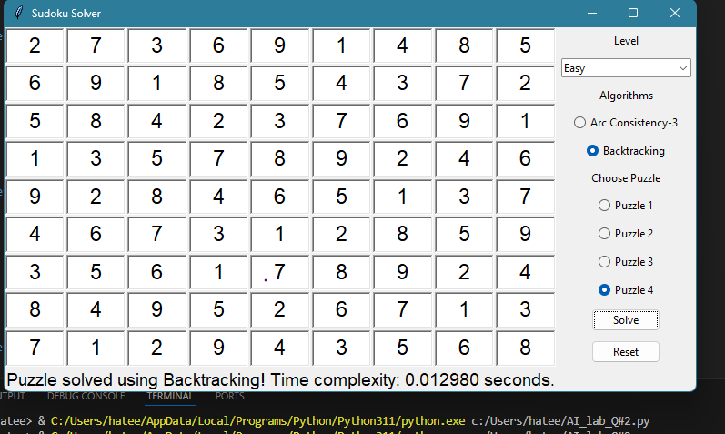

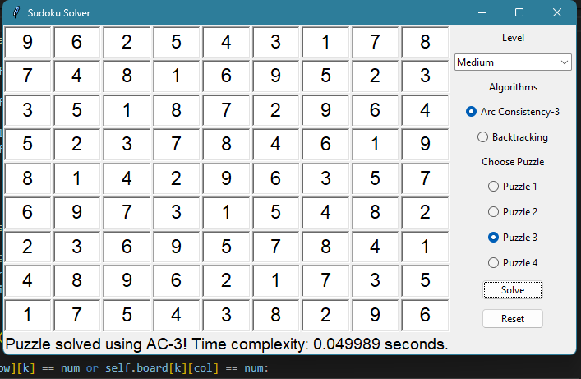  
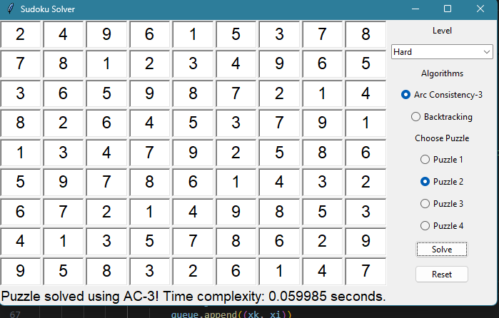

# QUESTION-3

import numpy as np

import pandas as pd

from sklearn.cluster import KMeans

import tkinter as tk

from tkinter import ttk, scrolledtext, filedialog

# Function to collect room capacities

def collect_room_capacities():

    # Simulated room capacities

    room_capacities = [30] * 25 + [35] * 4 + [25]

    return room_capacities

# Room Assignment Heuristic

def assign_clusters_to_rooms(df, capacities):

    cluster_counts = df['Cluster'].value_counts().sort_index()

    room_assignments = {}

    room_id = 0

    for cluster, count in cluster_counts.items():

        while count > 0:

            available_capacity = capacities[room_id]

            room_assignments.setdefault(room_id, []).append(cluster)

            count -= available_capacity

            room_id = (room_id + 1) % len(capacities)

    return room_assignments

# Faculty Assignment to Rooms

def match_faculty_to_rooms(assignments, faculties):

    faculty_assignments = {}

    for room, clusters in assignments.items():

        common_domain = students_df[students_df['Cluster'].isin(clusters)]['Domain'].mode()

        if not common_domain.empty:

            faculty = faculties[faculties['Expertise_Domain'] == common_domain.iloc[0]]

            if not faculty.empty:

                faculty_assignments[room] = faculty.iloc[0]['Faculty_ID']

            else:

                faculty_assignments[room] = "No faculty available for Domain"

        else:

            faculty_assignments[room] = "No common domain found"

    return faculty_assignments

# Reporting Function

def generate_report(room_assignments, faculty_room_assignments):

    report = "Seating Plan and Faculty Assignments Report\n\n"

    report += "Room Assignments:\n"

    for room, clusters in room_assignments.items():

        report += f"Room {room}: Clusters {clusters}\n"

    report += "\nFaculty Assignments:\n"

    for room, faculty in faculty_room_assignments.items():

        report += f"Room {room}: Faculty ID {faculty}\n"

    return report

# Save Report to File

def save_report(report):

    file_path = filedialog.asksaveasfilename(defaultextension=".txt", filetypes=[("Text files", ".txt"), ("All files", ".*")])

    if file_path:

        with open(file_path, "w") as file:

            file.write(report)

# Tkinter Application Setup

root = tk.Tk()

root.title("Exam Management System")

# Simulating Student Data

data = {

    'Student_ID': range(1, 2501),

    'Domain': np.random.choice([0, 1, 2, 3, 4], 2500),  # CS=0, AI=1, BA=2, SE=3, EE=4

    'Batch': np.random.choice([19, 20, 21, 22, 23], 2500)

}

students_df = pd.DataFrame(data)

# K-Means Clustering

kmeans = KMeans(n_clusters=30, random_state=0)

students_df['Cluster'] = kmeans.fit_predict(students_df[['Domain', 'Batch']])

# Simulating Faculty Data

faculty_data = {

    'Faculty_ID': range(1,31),

    'Expertise_Domain': np.random.choice([0, 1, 2, 3, 4], 30)

}

faculty_df = pd.DataFrame(faculty_data)

# Room capacities

room_capacities = collect_room_capacities()

# Assign clusters to rooms

room_assignments = assign_clusters_to_rooms(students_df, room_capacities)

# Faculty assignment to rooms

faculty_room_assignments = match_faculty_to_rooms(room_assignments, faculty_df)

# Generate report

report = generate_report(room_assignments, faculty_room_assignments)

# Seating Plan and Faculty Assignment Display

report_text = scrolledtext.ScrolledText(root, width=80, height=20)

report_text.pack()

report_text.insert(tk.INSERT, report)

# Button to Save Report

save_button = ttk.Button(root, text="Save Report", command=lambda: save_report(report))

save_button.pack()

root.mainloop()

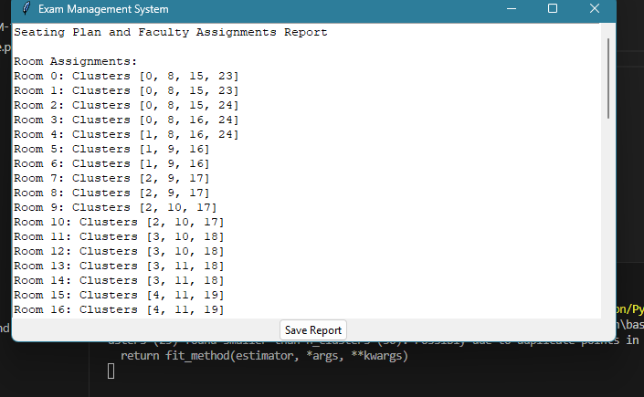

# QUESTION-4

import numpy as np

from sklearn.datasets import load_iris

from sklearn.model_selection import train_test_split

from sklearn.preprocessing import StandardScaler

# Load Iris dataset

iris_data = load_iris()

X = iris_data.data

y = iris_data.target

# Divide the dataset into training and testing sets using a 70/30 ratio

X_train, X_test, y_train, y_test = train_test_split(X, y, test_size=0.3, random_state=42)

# Standardize features

scaler = StandardScaler()

X_train_std = scaler.fit_transform(X_train)

X_test_std = scaler.transform(X_test)

# Add bias term to input features

X_train_bias = np.c_[np.ones((X_train_std.shape[0], 1)), X_train_std]

X_test_bias = np.c_[np.ones((X_test_std.shape[0], 1)), X_test_std]

# Implement the Perceptron Learning Rule

class PerceptronLearningRule:

    def __init__(self, num_features, learning_rate=0.01):

        self.weights = np.zeros(num_features + 1)

        self.learning_rate = learning_rate

    def _activate(self, x):

        return np.where(x >= 0, 1, 0)

    def _predict(self, x):

        return self._activate(np.dot(x, self.weights[1:]) + self.weights[0])

    def train(self, X, y, epochs=100):

        for _ in range(epochs):

            for xi, yi in zip(X, y):

                prediction = self._predict(xi)

                error = yi - prediction

                self.weights[1:] += self.learning_rate * error * xi

                self.weights[0] += self.learning_rate * error

    def evaluate(self, X, y):

        predictions = self._predict(X)

        accuracy = np.mean(predictions == y)

        return accuracy

# Implement sigmoid activation function for Gradient Descent Delta Rule

def sigmoid(z):

    return 1 / (1 + np.exp(-z))

class GradientDescentDeltaRule:

    def __init__(self, num_features, learning_rate=0.01):

        self.weights = np.zeros(num_features + 1)

        self.learning_rate = learning_rate

    def _predict(self, X):

        z = np.dot(X, self.weights[1:]) + self.weights[0]

        return sigmoid(z)

    def train(self, X, y, epochs=100):

        for _ in range(epochs):

            predictions = self._predict(X)

            error = y - predictions

            gradient = np.dot(X.T, error) / len(X)

            self.weights[1:] += self.learning_rate * gradient

            self.weights[0] += self.learning_rate * np.mean(error)

    def evaluate(self, X, y):

        predictions = self._predict(X)

        predictions = np.where(predictions >= 0.5, 1, 0)

        accuracy = np.mean(predictions == y)

        return accuracy

# Adjust the learning rates of the models

learning_rate_perceptron = 0.1

learning_rate_gradient_descent = 0.01

# Perceptron Learning Rule

plr = PerceptronLearningRule(X_train_bias.shape[1], learning_rate_perceptron)

plr.train(X_train_bias, (y_train == 2).astype(int))

accuracy_perceptron_train = plr.evaluate(X_train_bias, (y_train == 2).astype(int))

accuracy_perceptron_test = plr.evaluate(X_test_bias, (y_test == 2).astype(int))

print("Perceptron Learning Rule:")

print("Accuracy (Train):", accuracy_perceptron_train)

print("Accuracy (Test):", accuracy_perceptron_test)

# Gradient Descent Delta Rule with sigmoid activation function

gddr = GradientDescentDeltaRule(X_train_bias.shape[1], learning_rate_gradient_descent)

gddr.train(X_train_bias, (y_train == 2).astype(int))

accuracy_gradient_descent_train = gddr.evaluate(X_train_bias, (y_train == 2).astype(int))

accuracy_gradient_descent_test = gddr.evaluate(X_test_bias, (y_test == 2).astype(int))

print("\nGradient Descent Delta Rule with Sigmoid Activation:")

print("Accuracy (Train):", accuracy_gradient_descent_train)

print("Accuracy (Test):", accuracy_gradient_descent_test)

